**OBJECT ORIENTED PROGRAMMING LABORATORY**

**19Z311**



**EXPERIMENT: 3**

**JAVA BASICS**

**ABINAV P**

**22z201**

**BE CSE G1**

**1. Find greatest of Two numbers [ if,else] :**

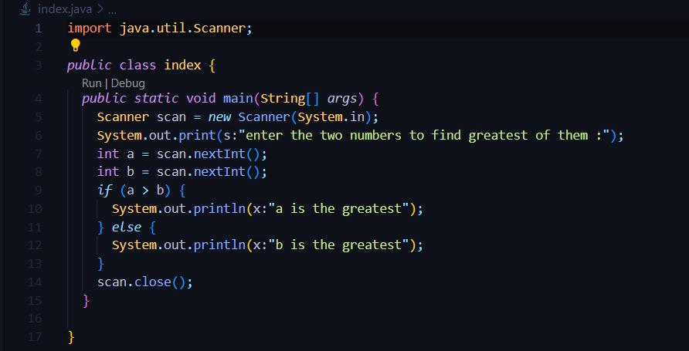

**O/P:**

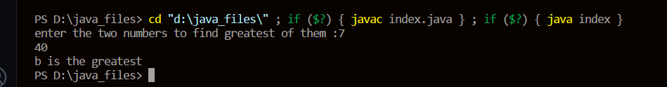

**2.Prepare Grade sheet for a student [ if..else if ]**

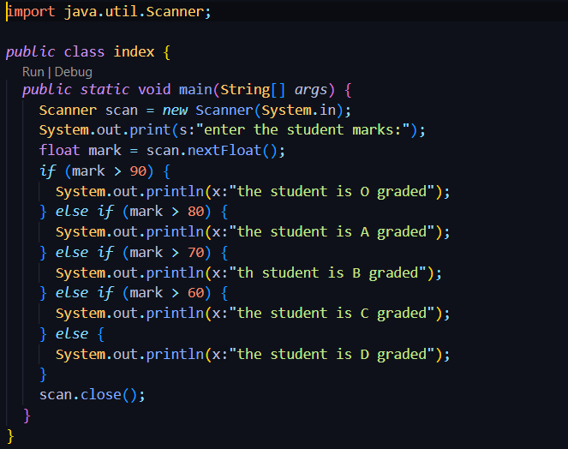

**O/P:**

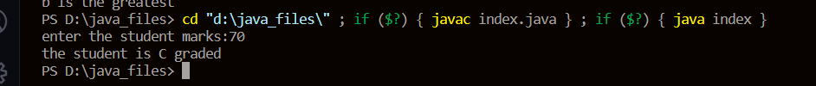

**3. Check whether the given number is positive, negative or zero [ if..else if]**

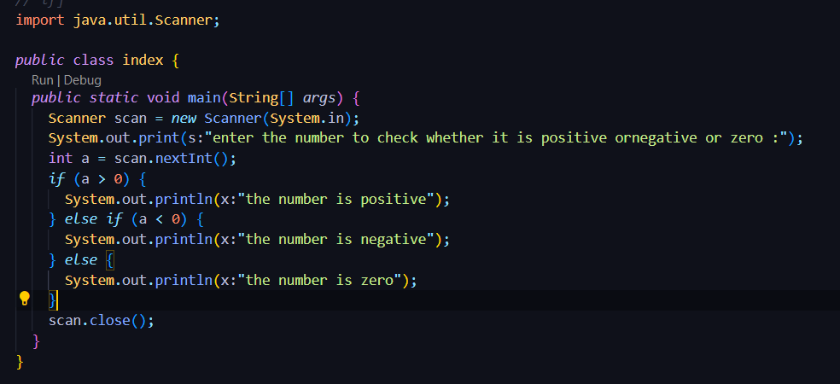

**O/P:**

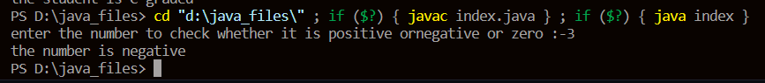

**4. Take the length (L) and breadth (B) of the rectangle as input and find its area**

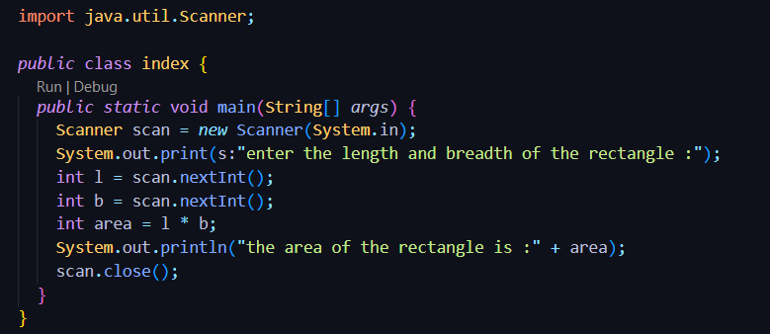

**O/P:**

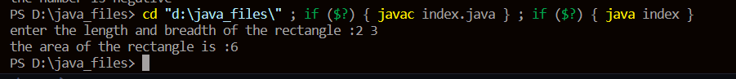

**5. You have been given a number 'N'. Your task is to find the sum of all even numbers from 1 to N**

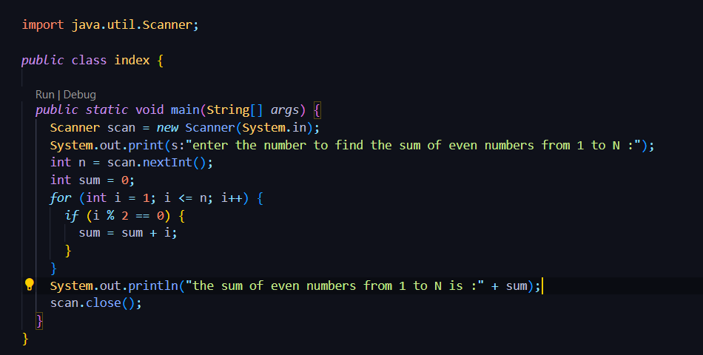

**O/P:**

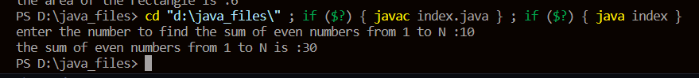

**6. For the given integer just print the sum of all even digits and odd digits separately.**

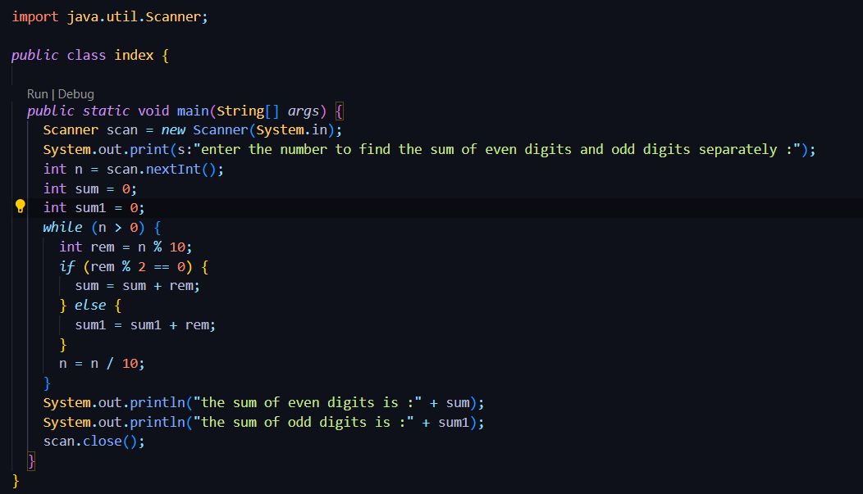

**O/P:**

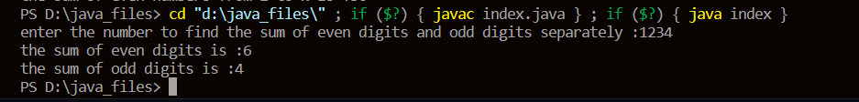

**7. Write java program to print the pattern. [Nested for loop ]**    *  
    *    *  
    *     *    *  
    *     *     *     *  
    *      *     *     *    *

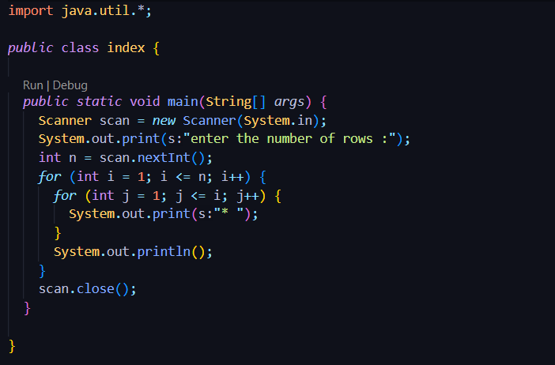

**O/P:**

